Dear 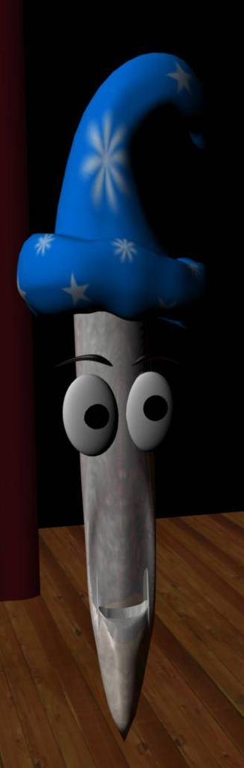 Magic Musician,

It was such fun meeting you! I would not have believed that such a ………….…….. sound could come from just one instrument!

It was fun to see and hear the different types of pipes. The long pipes made ………….….. sounds, and the ………….…… ones made high sounds, didn’t they. They had lots of different shapes too, and so many varied tones when the air went through them. The organ can sound happy or ………….…, or …………….… or soft, or …………….…., or grand, or any way you want!

There was not one just one keyboard but ……….……... – two to play with my hands and one for my ………..….….. Pressing the ……….….……. made the different notes sound. I could choose the sounds by pulling out the switches at each side. There was a lot to learn, but I did enjoy it, especially playing so many ……….….….. together – it sounded …….……….….

I am looking forward to learning to play properly – I will find an organ to visit, and someone to help me learn, by asking Mum or Dad or my teacher to look on www.DanMagic.org

Best wishes from 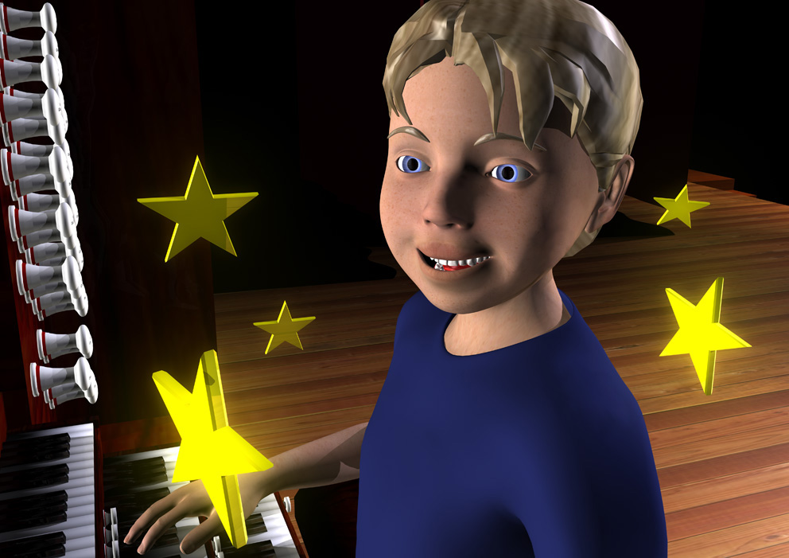 Dan

