My Name…………………………….. Today is……………………………..

Our visit to see and hear a Pipe Organ

1 The organ we are visiting is at ………………………………………………………………………....

2 The organist is called ……………………………………………………………………………….…..

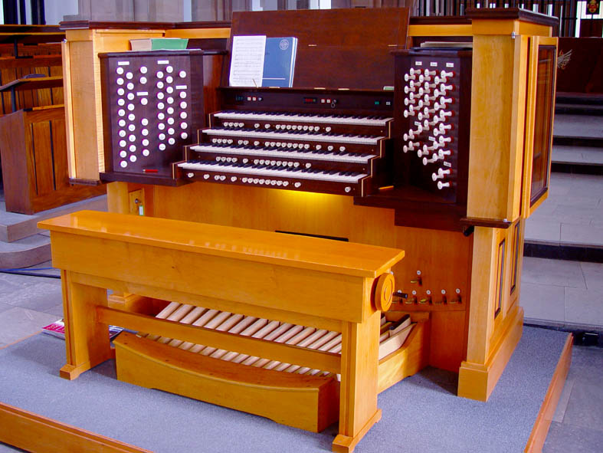 3 How many keyboards does this organ have? ………………………………..

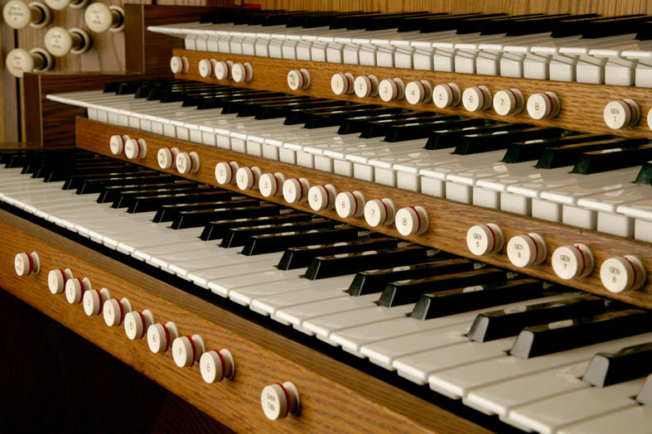 4 How many notes are there on each keyboard played with the hands (called manuals)?…………………………………………………………………………

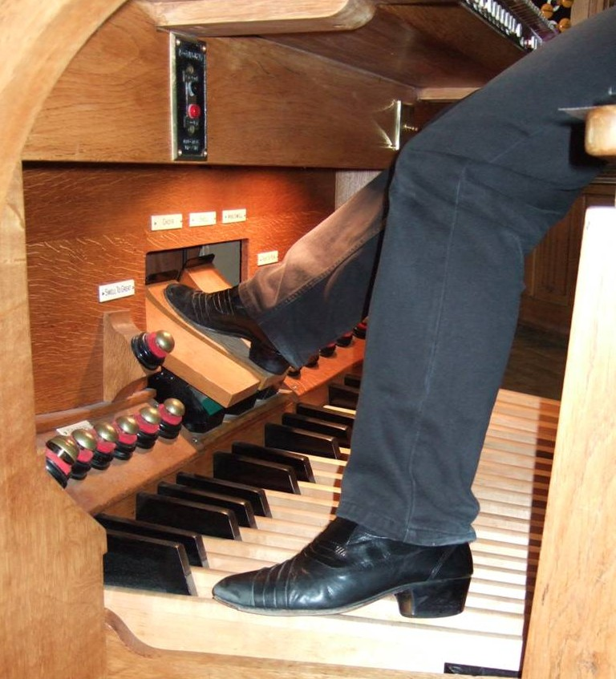 5 How many notes are there on the pedalboard?...................……………….

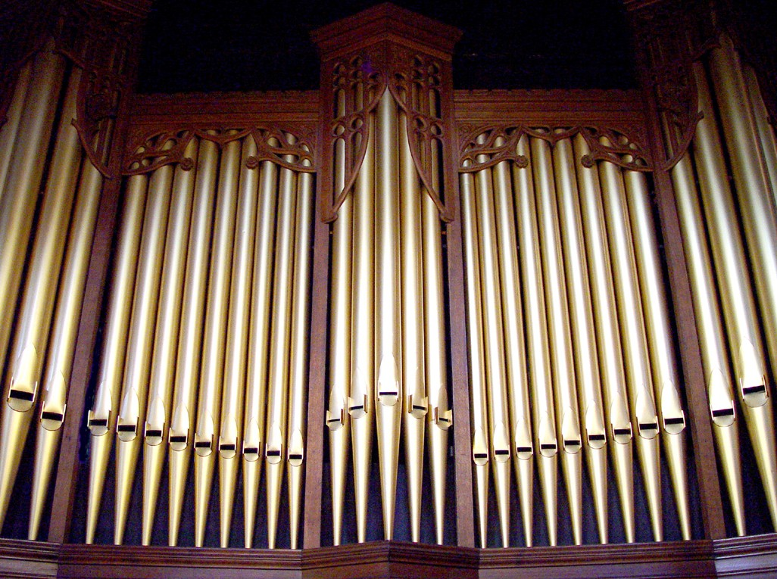 6 How many pipes can you count around the outside of this organ?..………

7 What colour are they?...................…………………………………………….

8 Are they made of wood or of metal?...................………………………….…

9 Ask the organist: how many pipes there are inside this organ?...............

10 What makes the pipes sound?..................................................................

11 How many switches are there on this organ for choosing different sounds?........................................................................................................
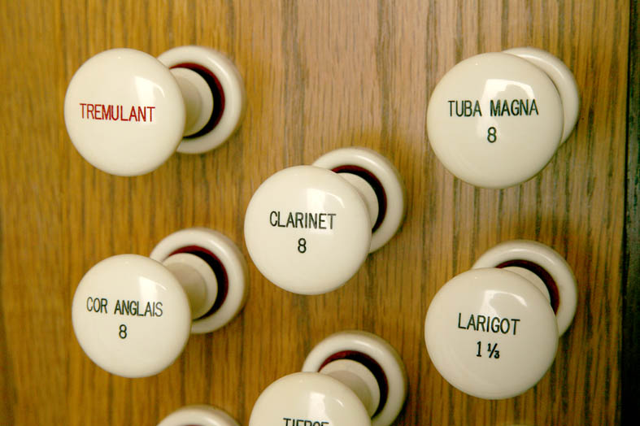 12 Do they look like this (these are drawstops)?...................………………….

13 If not, can you draw what they look like?

The different pipe shapes make different sounds, and they have their own names too. Have you heard:
14 Principal pipes playing a tune……………………………………………………………..

15 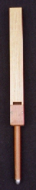 Some gentle sounds from the Flute pipes……………………………………………..

16 Soft sounds from the String pipes……………………………….…………………………..

17 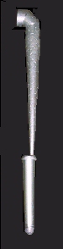 Loud sounds from the Reed pipes………………………………………………………..

18 Some very high notes……………………………………………………..…………………..

19 Some very low notes…………………………………………………………………………..

20 Pipes sounding all together in chorus………………………………………………………..

20 Have you had a go at playing the organ? ……………………………………………………………..

21 Draw a picture of this organ here

The organ can sound happy or mysterious or loud or soft or excited or grand!
And don’t forget – it’s the Greatest Musical Instrument of ALL!

Thanks to John Chapman for many of the photographs in this worksheet

