Calling all Music teachers!

in infants, primary and junior schools (KS1 and KS2)

“Dan and the Magic Musician”
is an animated story introducing children to the pipe organ
in a fun way

A child, in company with a Magic Musician, meets all the parts of “the greatest musical instrument of all”, but can’t guess what it is until they all come together.

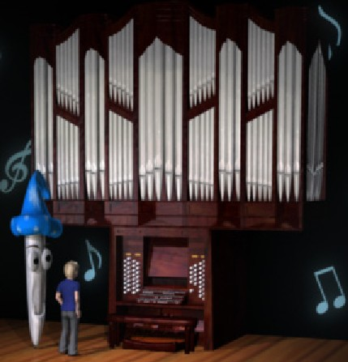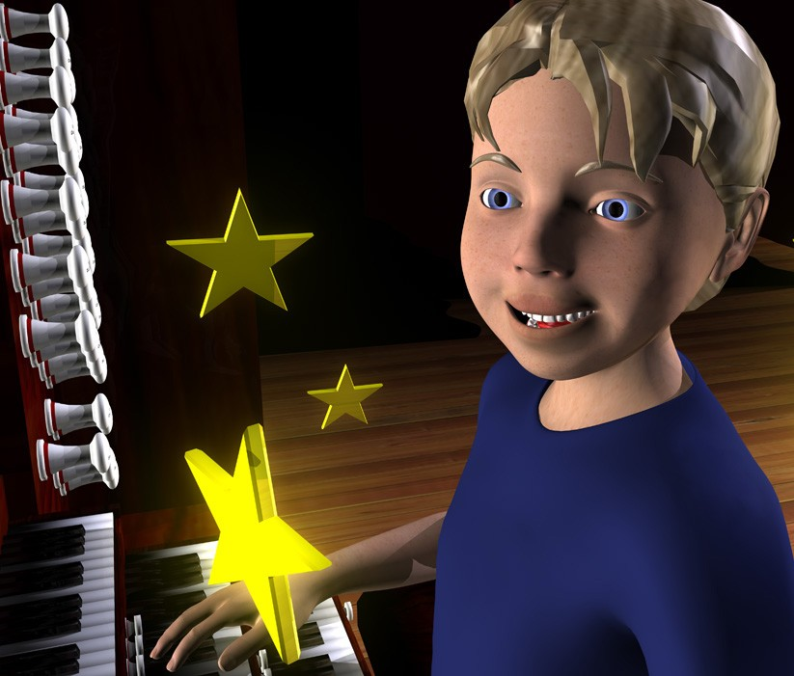

This FREE resource for teachers (and individuals) is an initiative from the Royal College of Organists.

You can view the animation directly, or download it, or get a DVD, from the website

www.DanMagic.org

Also on the website are follow-on materials to use after viewing the story - resources to help prepare lessons about pipe organs, contacts for arranging visits to a local pipe organ (and visit worksheets), and lots of links to other useful information and contacts.

Do have a look at what is available, and do use it to include
finding out about the pipe organ in YOUR music lessons!

